Session Title: The Student Perspective: What International Students Want HE Professionals to Know

What can we learn when we stop talking about international students and instead listen to them?
Join the AHEP International HE Special Interest Group and UKCISA's International Student Ambassadors for a focused panel discussion exploring the experiences of international students studying in the UK.
Drawing on questions submitted by AHEP members, our student ambassadors will share their perspectives on key moments of the international student journey, from choosing the UK and navigating the Student visa process to settling into university life, accessing support, and planning for future careers. They'll discuss what exceeded expectations, what proved challenging, and what they wish universities had done differently along the way.
Rather than attempting to cover every aspect of the international student experience, this session offers an opportunity to hear authentic student voices, explore the issues that matter most to them, and ask your own questions during the live Q&A.
Whether you work in admissions, compliance, student support, academic services or another area of higher education, this session invites you to reflect on how your everyday interactions, institutional processes and communications influence the student experience. Together, we'll explore what compassionate, student-centred communication looks like in practice and consider how listening to students can inspire meaningful improvements to the way we support international students throughout their journey.

Speakers:

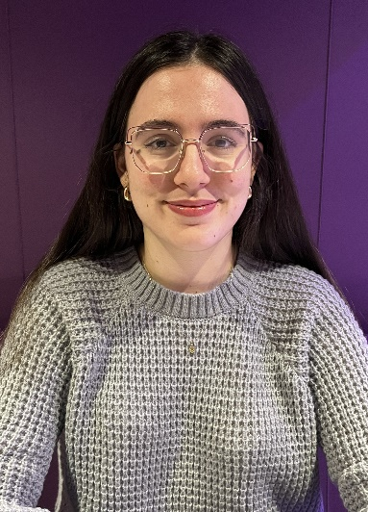
Amina Manal Zidi, University of the West of Scotland, Algeria
Amina Manal Zidi, is a PhD graduate from the University of the West of Scotland researching international student mobility and the reintegration experiences of Algerian doctoral returnees. Her policy interests centre on international education, student transitions, and improving support systems for global learners. As a #WeAreInternational Student Ambassador she hopes to contribute evidence-informed insights, represent diverse student voices, and advocate for fairer, more inclusive policies.

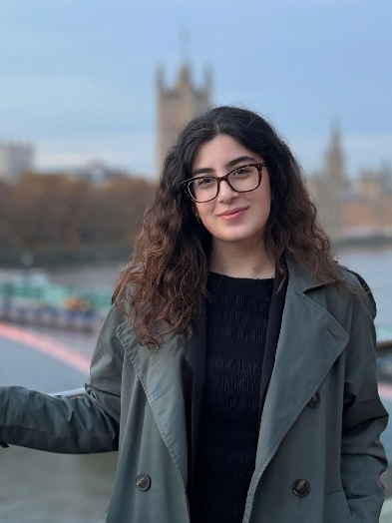
Saba Movahed Nia, Queen Mary University of London, Iran
Saba is an LLM student in Public International Law at Queen Mary University of London. Throughout her studies in bachelor's in law at Coventry University, she has been actively involved in student union work, served as a School Representative, and contributed to pro-bono legal clinics and legal education outreach, alongside wider volunteering supporting migrant and refugee communities. Her undergraduate years strengthened her commitment to inclusive student support and advocacy. Saba’s policy interests center on fostering belonging and improving mental health for international students. Through #WeAreInternational, she hopes to promote equitable wellbeing policies and create environments where international students feel valued and empowered.

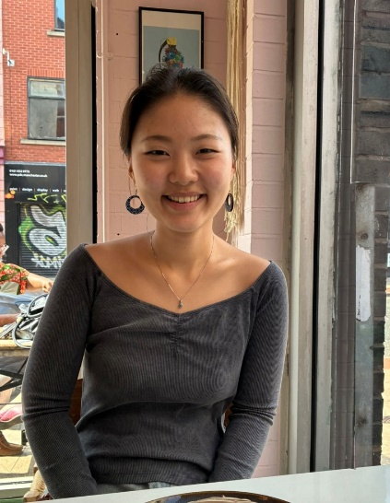
Serin Baek, University College London, South Korea
Serin is a third-year MSci Pharmacology student at UCL. Her diverse background, rooted in Korea and Cambodia, fuels her dedication to improving the international student experience. She is committed to advancing policies that ensure talented international students successfully transition into the UK workforce. Her primary interest is tackling the structural barriers that hinder job security and maximizing the utility of the post-study work visa. She aspires to take part in the #WeAreInternational Student Ambassador Programme to directly advocate for changes in employability policy and drive tangible support.

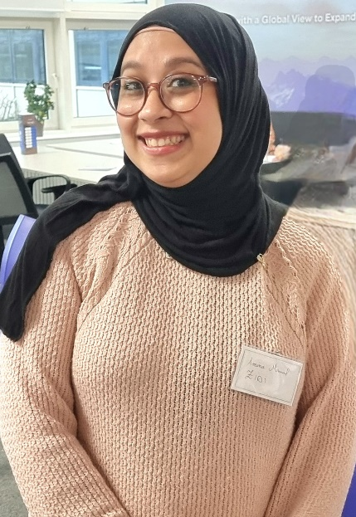
Arya Nur Güneş, Royal Academy of Music (UG), Türkiye
Arya Güneş is a fourth-year undergraduate student from Türkiye, currently pursuing a Bachelor’s degree in Cello Performance at the Royal Academy of Music. Furthermore, she is in her first year at the National University of Distance Education of Spain, studying business. Her main objective as a UKCISA ambassador is to challenge the rapidly rising tuition fees for international students and advocate for more funding to be made available, especially for students of lower economic backgrounds. She is particularly interested in influencing policymaking through collaborating actively with fellow students to make sure everyone’s opinion and voices are heard.

Please note that this session will not be recorded.
Bookings

AHEP Members: book your place here!
UKCISA colleagues: book your place here!

