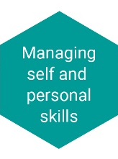
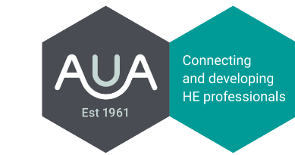
Managing self and personal skills
Being aware of own behaviour and mindful of how it impacts on others, enhancing personal skills to adapt professional practice accordingly.
Self
Indicator | How I do/have done this | How I could start/continue to do this
Being well prepared for meetings and presentations
Demonstrating an awareness of own values, motivations and emotions
Keeping up to date with what is happening in professional area
Having an enthusiastic and positive ‘can-do’ approach
Maintaining a healthy life balance
Speaking and writing by using clear succinct language
Showing consistency between words and actions
Being self-motivated
Accepting and demonstrating personal responsibility for health and safety, data protection and other compliance areas

Others
Indicator | How I do/have done this | How I could start/continue to do this
Giving and receiving constructive feedback as part of normal day-to-day work activity
Developing and maintaining personal networks of contacts
Ensuring own behaviour, words and actions support a commitment to equality of opportunity and diversity
Chairing meetings effectively, ensuring everyone has an opportunity to contribute
Getting the best from others through effective communication
Managing own response when faced with challenging situations
Ensuring that own behaviours consistently provide a positive role model

Organisation
Indicator | How I do/have done this | How I could start/continue to do this
Applying personal skills appropriately to represent the organisation positively
Recognising personal accountability to the organisation through your work and interactions

Examples of behaviours that may indicate a need for further development in managing self and personal skills

- Talking or writing at inappropriate length
- Focusing almost exclusively on own job or own department
- Being consistently late for meetings
- Missing deadlines
- Reacting defensively to constructive feedback
- Ignoring the views and suggestions of others

